**LAB 02 TASKS**

**Question#01) Print Diamond using escape sequence “\n” and “\t”? In single cout statement?**

**Output should be like**

**\***

**\* * \***

**\* * * * \***

**\* * \***

**\***

**Source Code: Ouput:**

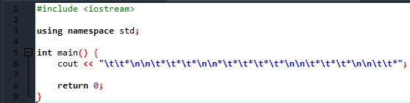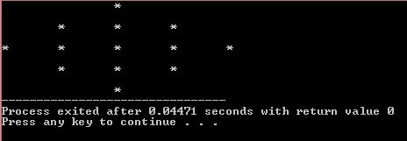

**Question #02) Print your Result Card using required escape sequences? Print all other information as it is but get input from user in obtained marks and calculate the percentage of entered marks?**

**Output:**

**Result Card**

**Name: ABC Reg. #: CIIT/---------**

**Session: Fall-16 Semester: 2**

**Subjects Total Marks Obtained Marks**

**Digital Logic Design 100 ___user input___**

**Electronics-I 100 ___user input___**

**English 100 ___user input___**

**Percentage= %**

**Source Code:**

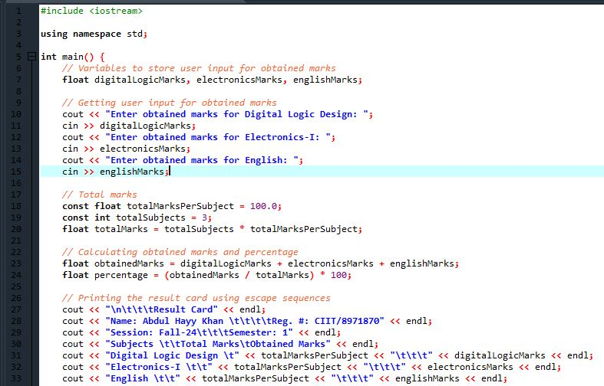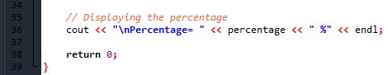

**Ouput:**

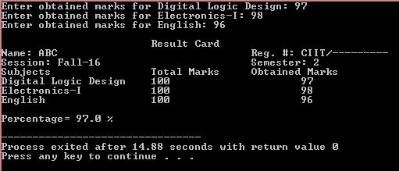

**Question#03) Develop a C++ program that declare almost 6 types of identifiers and display their sizes in bytes on the screen.**

**Source Code: Ouput:**

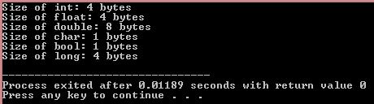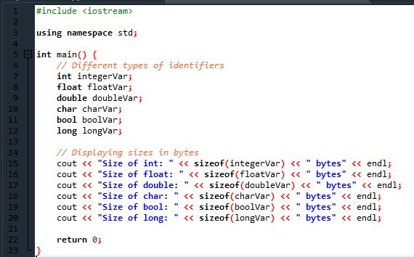

**Question #04**) **Develop a C++ program that prints the table of 2 without using loop?**

**Source Code: Ouput:**

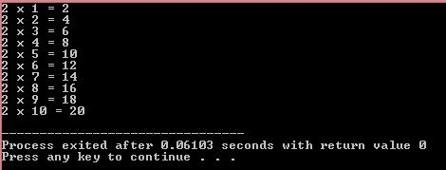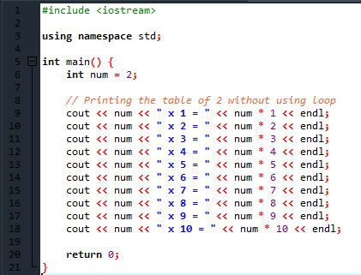

**Question #5**) **Write a program to swap the value of a and b**

**let a=10 and b = 20**

**your output should be**

**a = 20 and b = 10**

**Source Code: Ouput:**

